Operating systems   
Lab 2 - Report  
Deadlock prevention and detection

Nikolay Stroitsov

Adriana Bostandzhieva

Table of Contents

Deadlock prevention and detection 2

Description 2

Solution and Results 2

# Deadlock prevention and detection

## Description

The aim of the task is to implement a resource allocator which uses two deadlock algorithms for two groups of the resources and deadlock detection algorithm for the third group. The required deadlock detection algorithms are “no hold and wait “ and the Djikstra’s bankers algorithm.

The resource allocator implemented the required constructor and methods according to the ab assignment sheet.

## Solution and Results

The resource allocator was tested against a chosen set of processes that would lead to either blocking the process or deadlock. Some of the processes were control ones that just occupied resources.

Process 1:

* Non blocked: All required resources are granted;

Process 2:

* Blocked: there are not enough free resources to implement and hold and wait may occur;

Process 3:

* Non blocked: All required resources are granted;

Process 4 and 5:

* Deadlock occurs and the processes are killed.

Process 1 leaves.

The results of the simulation are shown on Figure 1.

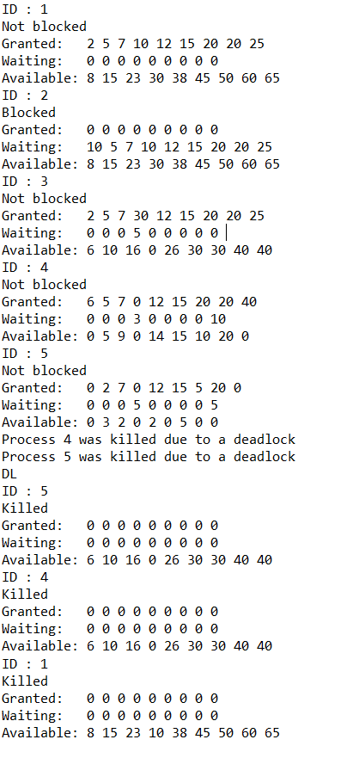

Figure . Results from simulation